6.63: See Problem 6.62: The work done is negative, and is proportional to the distance s that the package slides along the ramp, 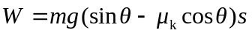. Setting this equal to the (negative) change in kinetic energy and solving for s gives
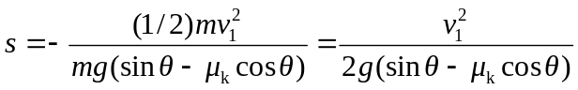
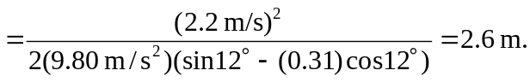
As a check of the result of Problem 6.62, 

